5.1 Designing The Map

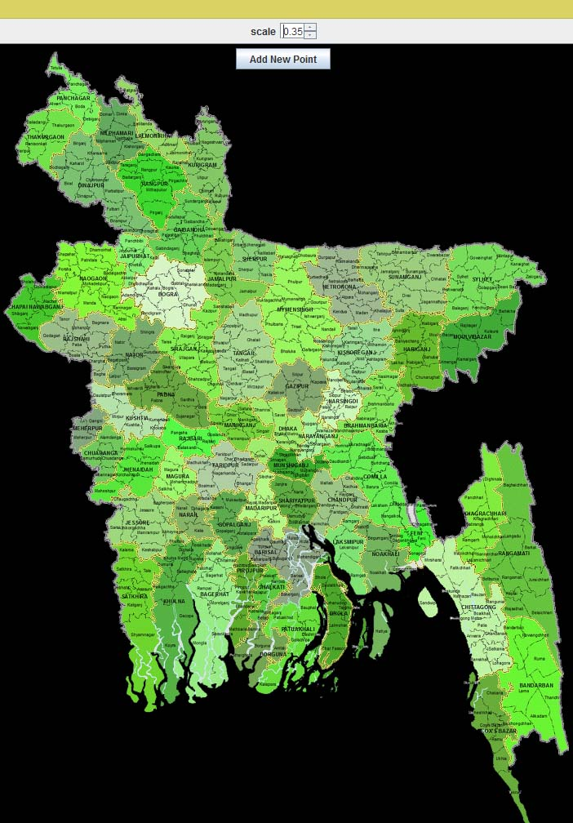We have a static High Quality Map of Bangladesh which have a resolution 2000 x 2731 (BangladeshMap.png). This map shows us all Divisions, Districts and Thanas of Bangladesh. Our static Map is shown below:

5.2 Plotting Data on map based on crime categories and location

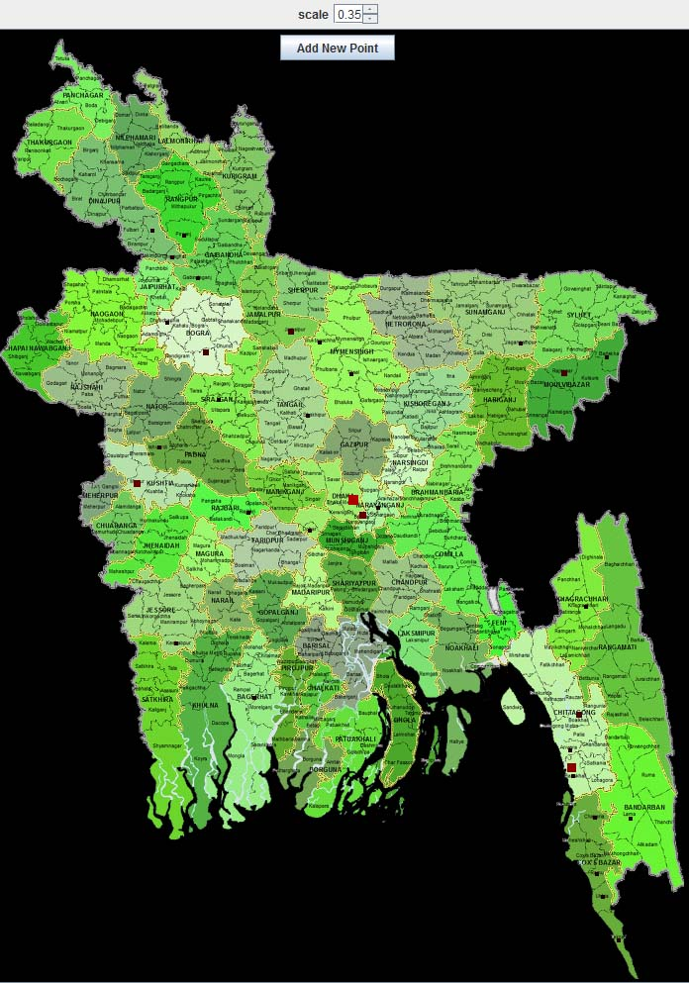We have stored the list of all location of Bangladesh consisting Division, District and Thana. The co-ordinate of all location relative to this map is also stored in a table. Now when we find a location of a crime we add dynamically a dot to the specific location. This feature is shown below:

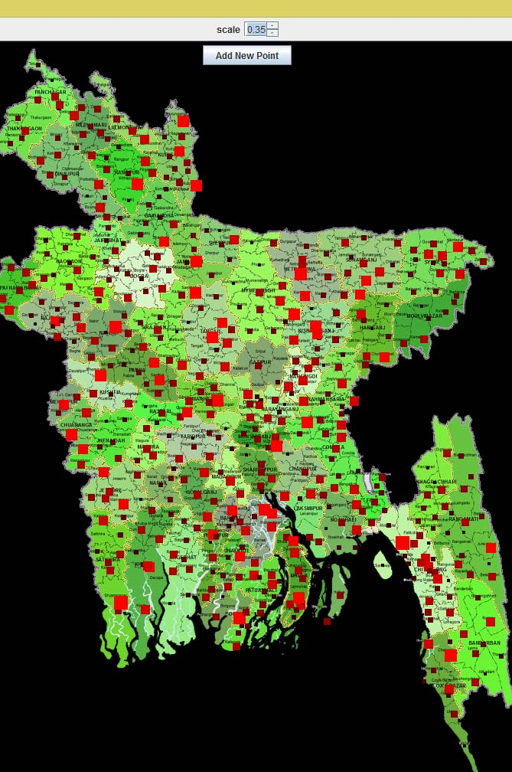When we find frequent location for different crime news, we just make it a larger dot than the previous. We also changed the color of dot redder. Here is the face of the map for huge crime statistics.